Process Document of User Guide for Company standard document Change Management
Submitted to:
Kirloskar Oil Engine Limited(KOEL)
Date: 13 February 2020

Submitted By:
Kloudq Technologies Limited
Plot No.1,Yena,Adwaitnagar,
Paud Phate,Erandawana,
Pune-411038,Maharashtra,INDIA

Document History:

Version | Author | Date | Comments
1.0 | Rushikesh Avhad | 12/02/2020 | First release
2.0 | Prashant Varaskar | 14/2/2020 | Modification

Table of Contents
1. Problem Report Creation: 4
2. Change Request Creation: 10
3. Change Notice Creation: 15
5. Result: 22

Problem Report Creation:
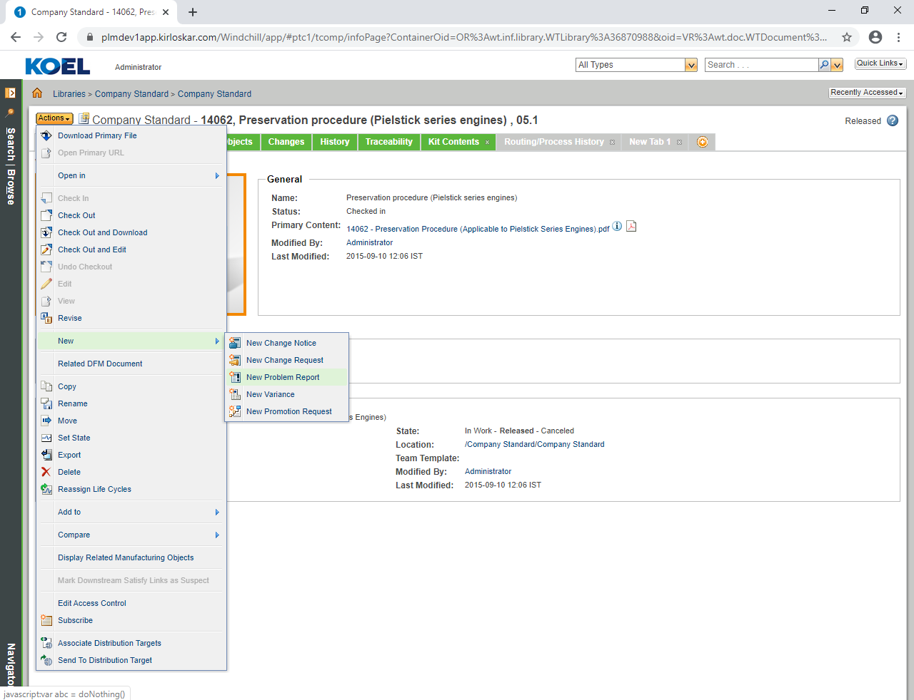
- Once Company Standard Document is created then create Problem Report.
- Navigate to Company Standard document then click on Action New New Problem Report, as seen in above figure

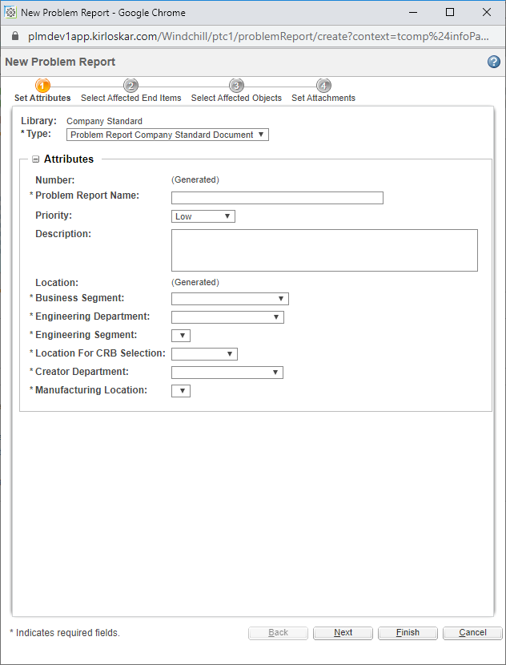
    - Select Type : Problem Report Company Standard Document and fill the above attributes details.
    - Then click on Next as seen in above figure

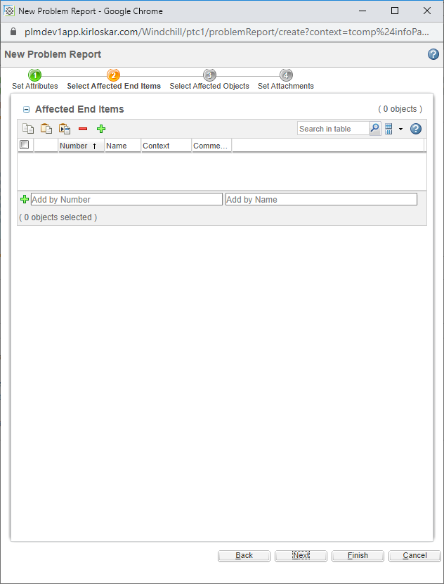
- You can add if any Affected End items. Then you can select Affected objects
- Then you can add any additional attachments here if any then click on Finish
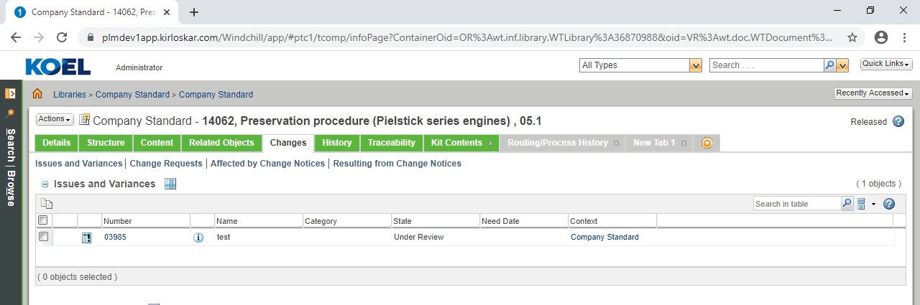
- Problem Report will be created and view it on changes tab, then click report to view

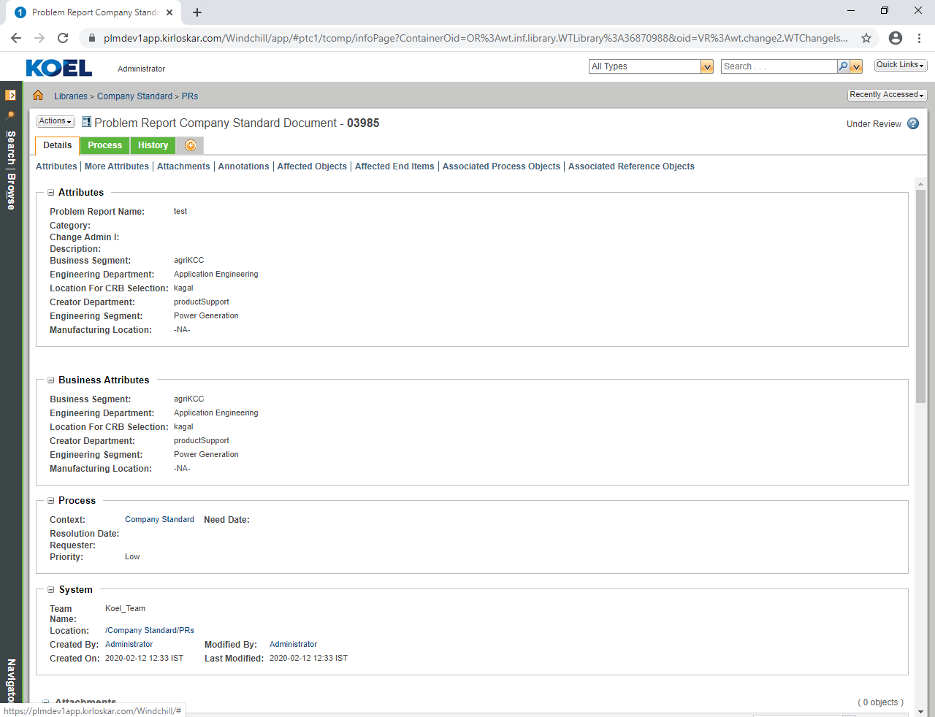
- The above figure shows Problem Report is created

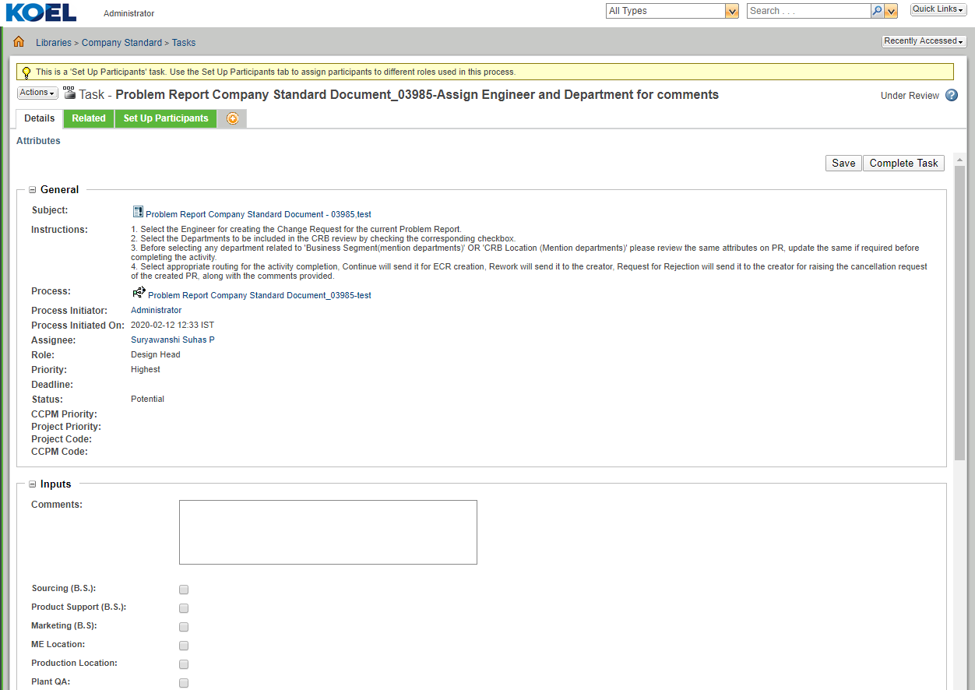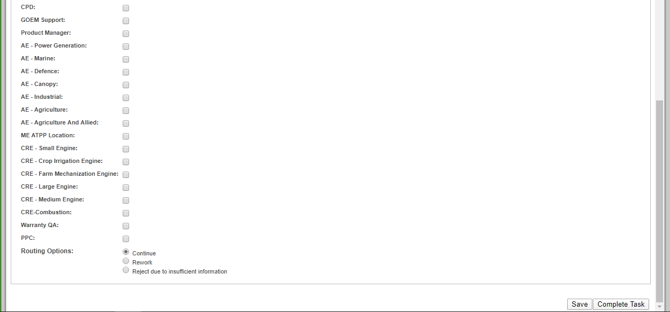
- For First Task assign engineer From Set up Participant tab and select departments for review. Then for Routing option select any check boxes.
- Continue :
- Rework:
- Reject due to insufficient information :
- Then complete the task, as seen in above figure

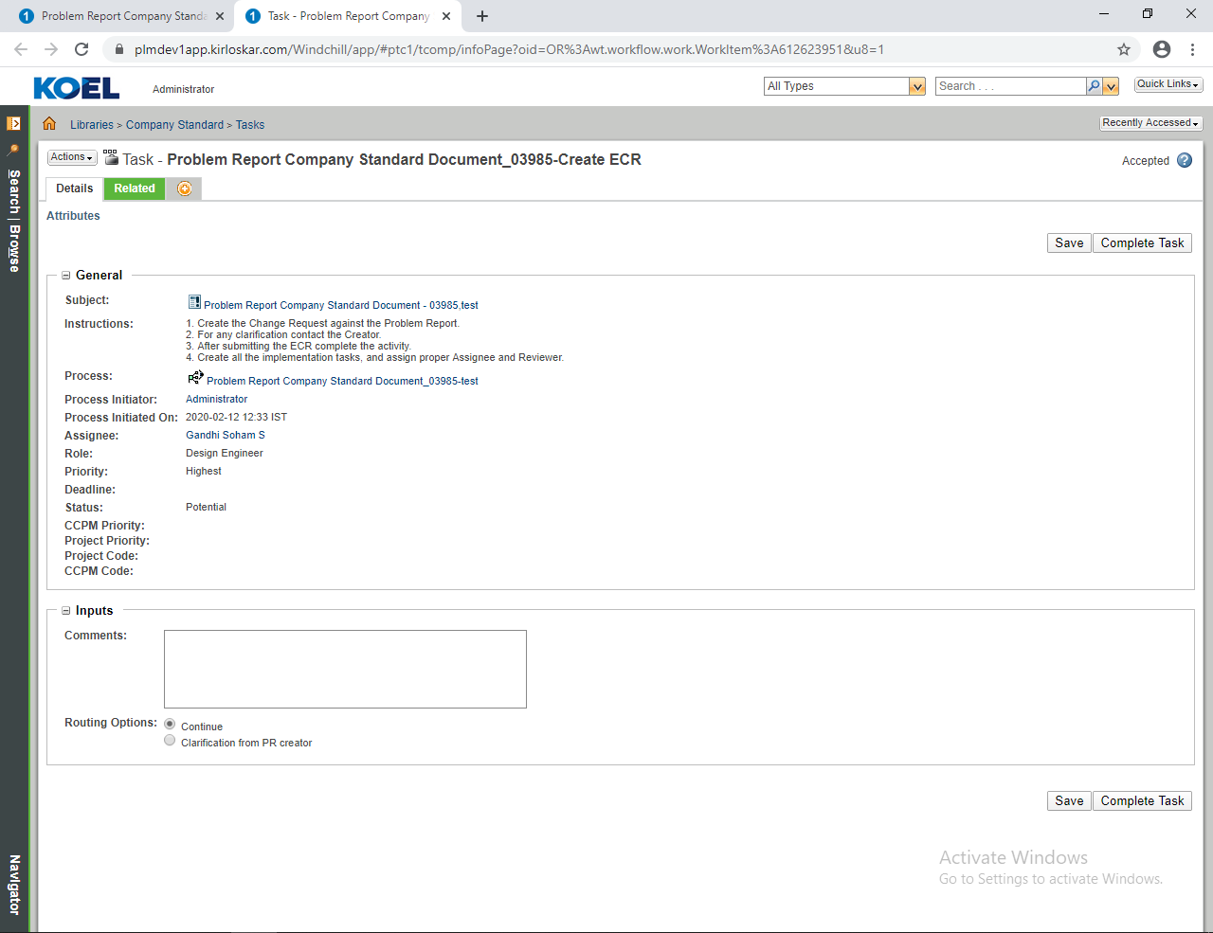
- For this task first create ECR .Provide necessary comments
- Routing select option.
- Continue :
- Clarification from PR Creator:
- Then complete the task

Change Request Creation:
Now Open PR and click on Actions New New Change Request.

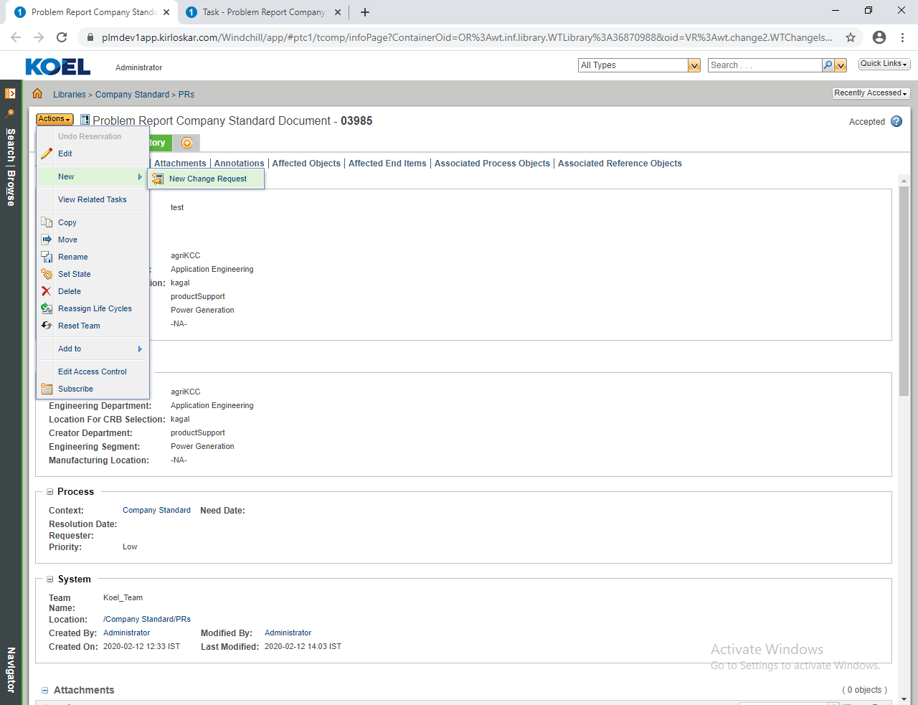
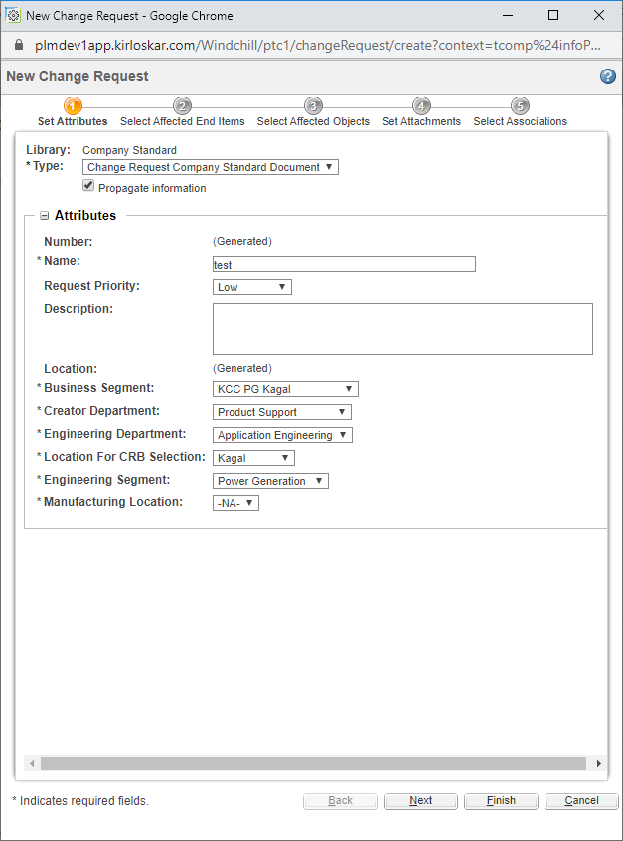
    - Select Type: Change Request Company Standard Document, Click on Propagate Information check box and then check all details.
    - Then click on Next

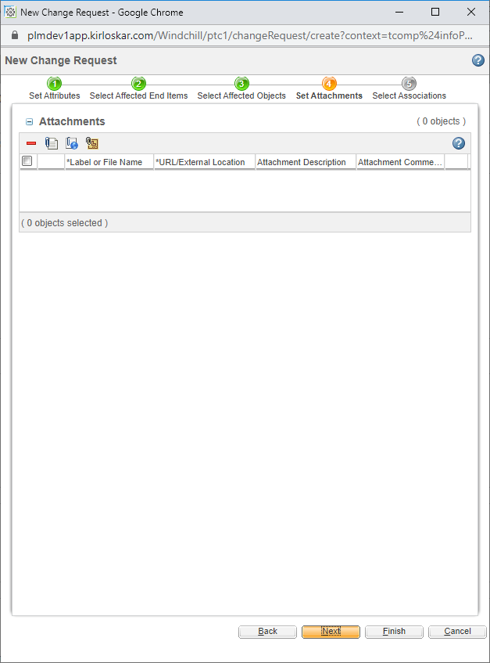
    - Here you can attached multiple documents .Then click on then Finish button

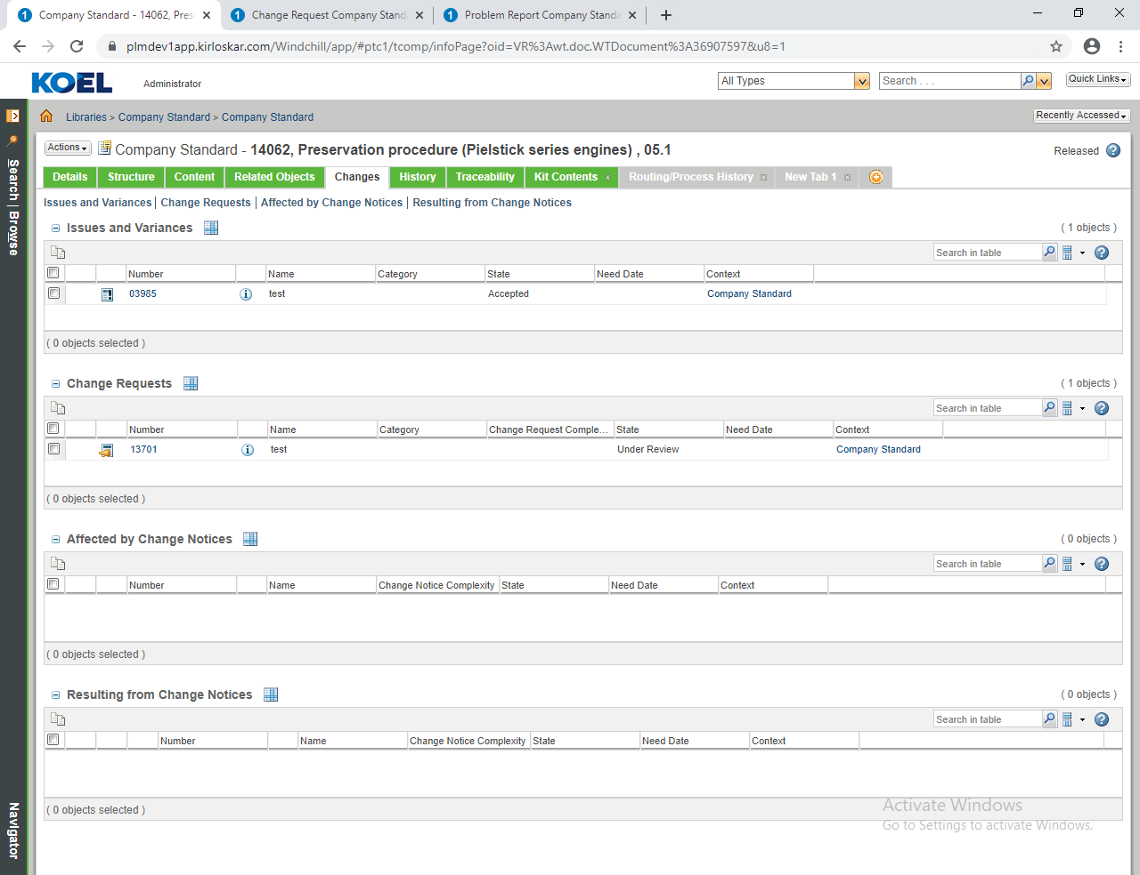
    - ECR will be created it will appear in changes tab company standard document.
    - Click on ECR to view details page.
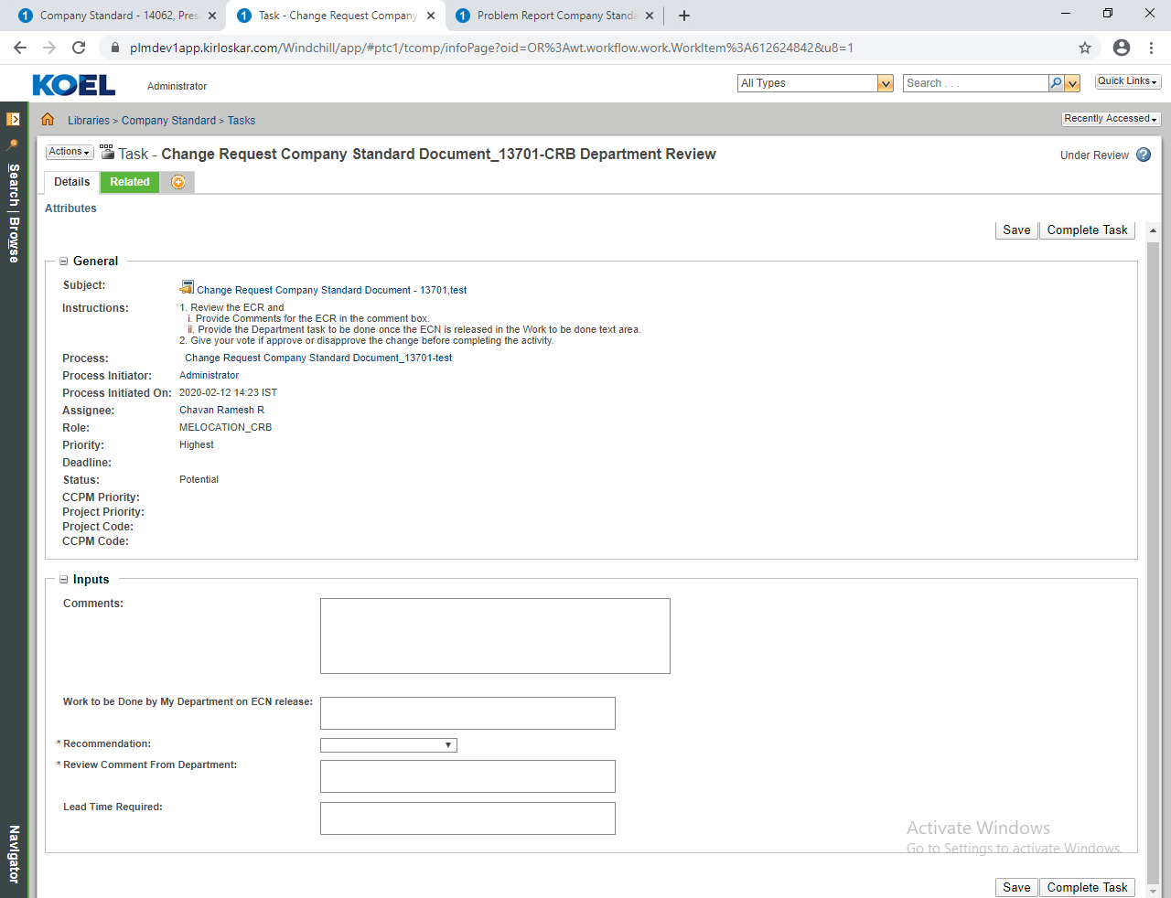
- In CRB Department Review task. Provide the above inputs which mandatory fields are.
- Provide necessary comments .Then provide the details for
- Work to be done by My department on ECN release
- Recommendations
- Review from Department
- Then complete the task
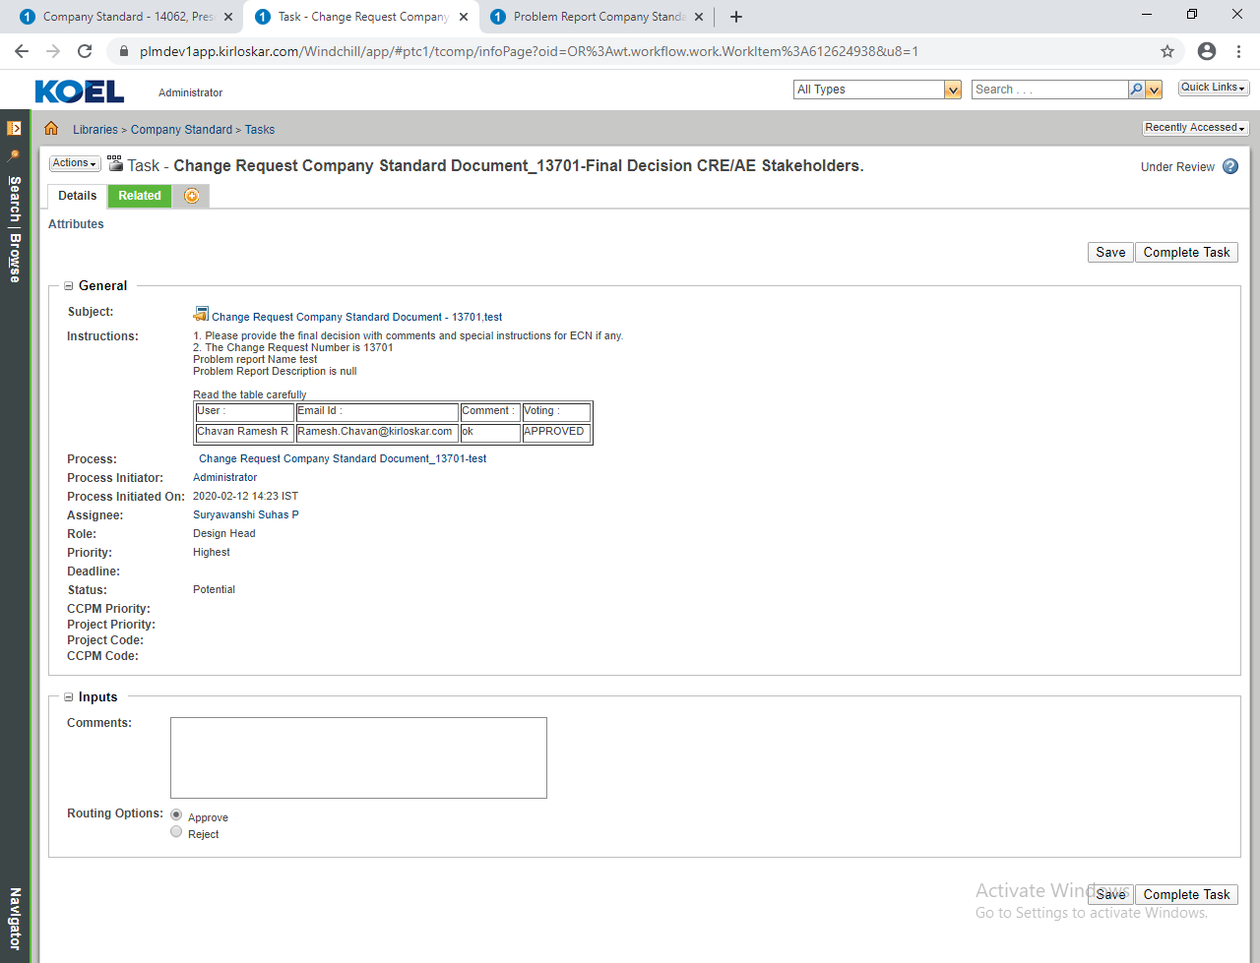
- In Final Decision CFE/AE Stakeholders task. Provide necessary comments
- Select the Routing options Approve/Reject and then complete the task.

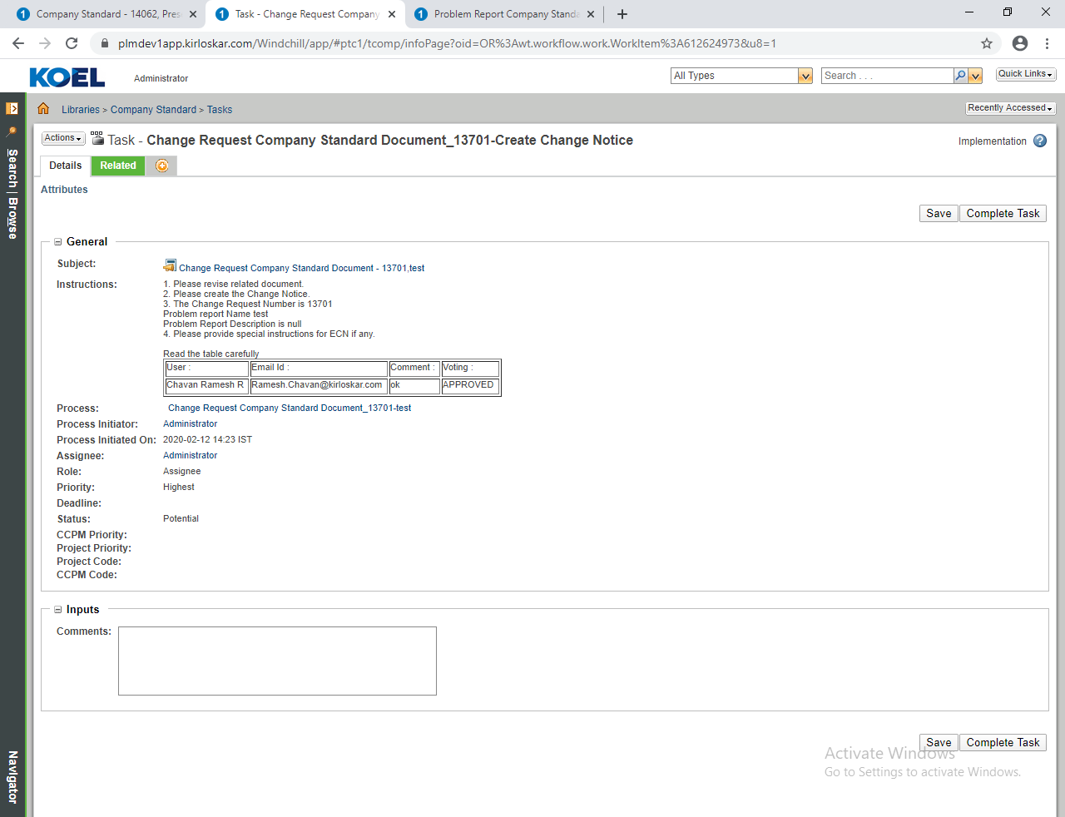
- Provide necessary comments. For this task first create ECN on ECR then complete this task.

Change Notice Creation:
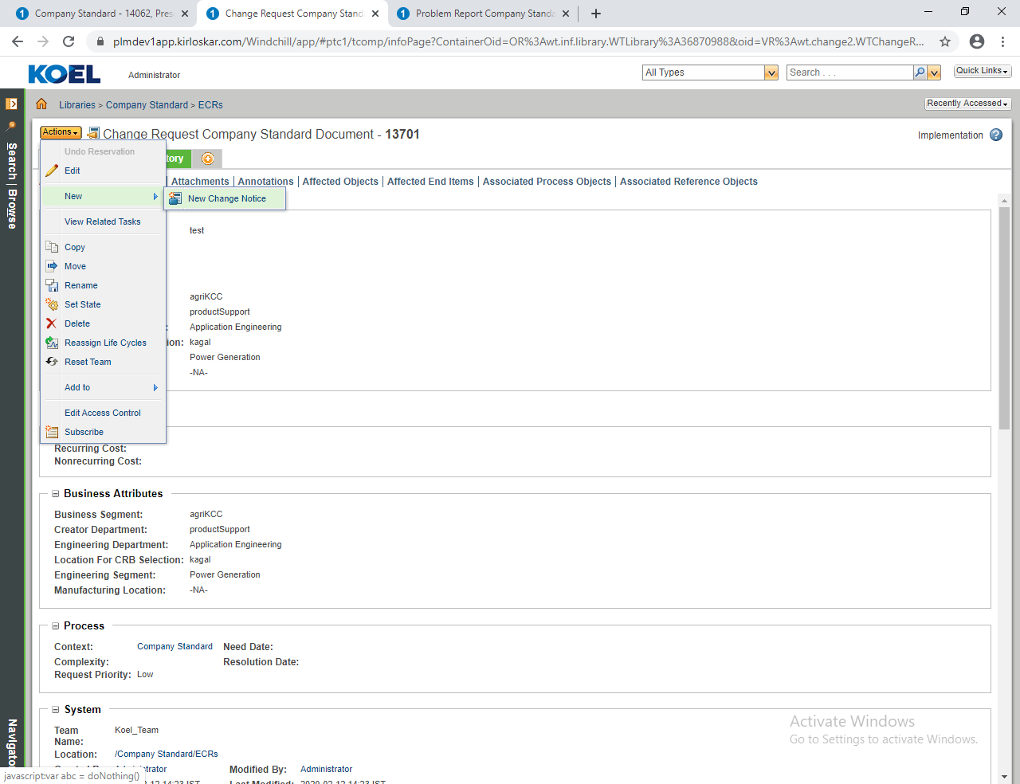
- In Co. Standard Document of Change request. Navigate ActionNewNew Change Notice, as seen in above figure
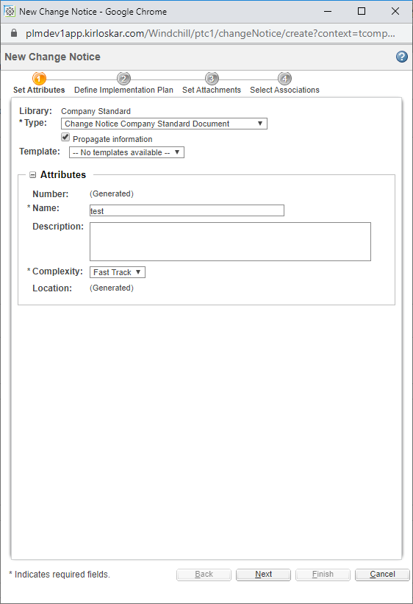
- Select type Change Notice Company Standard Document, click on Propagate Information check box and check details
- Then click on Next.

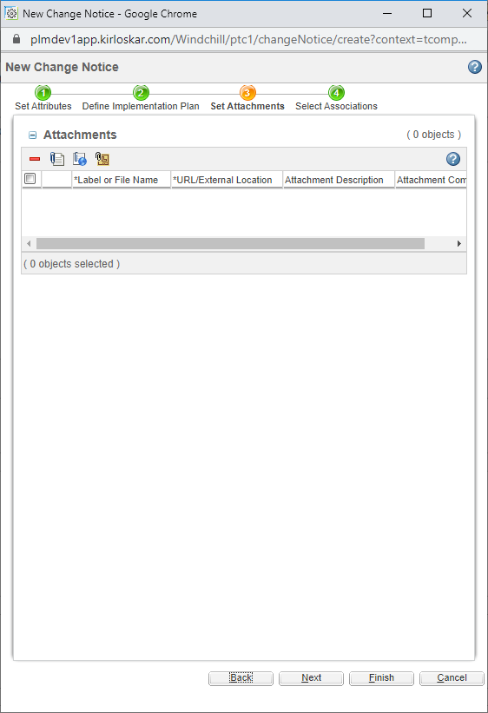
- In Attachments you can attach additional document. Then click on finish button

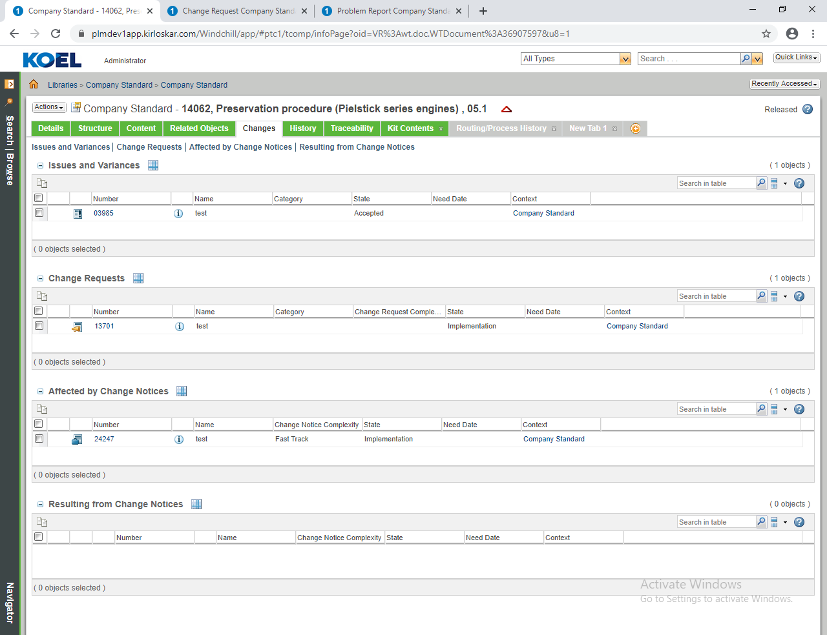
- Once ECN is created it will appear in changes tab of company standard document, as seen in above figure

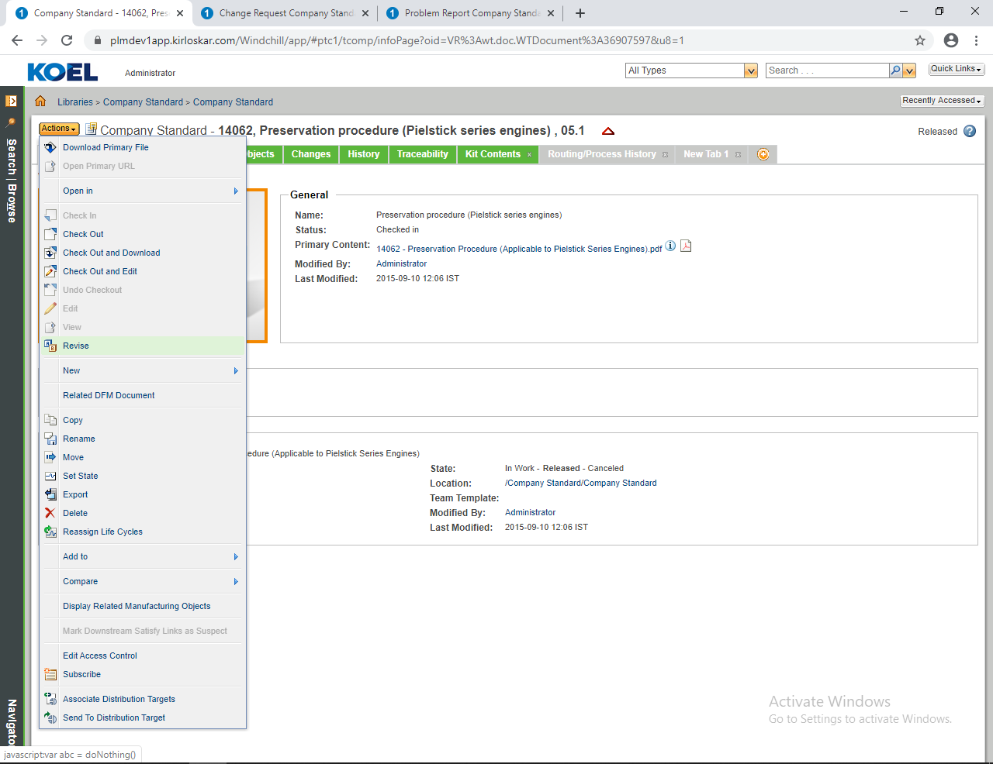
- After creation of ECN . Revise the company standard document by navigating Actions Revise.

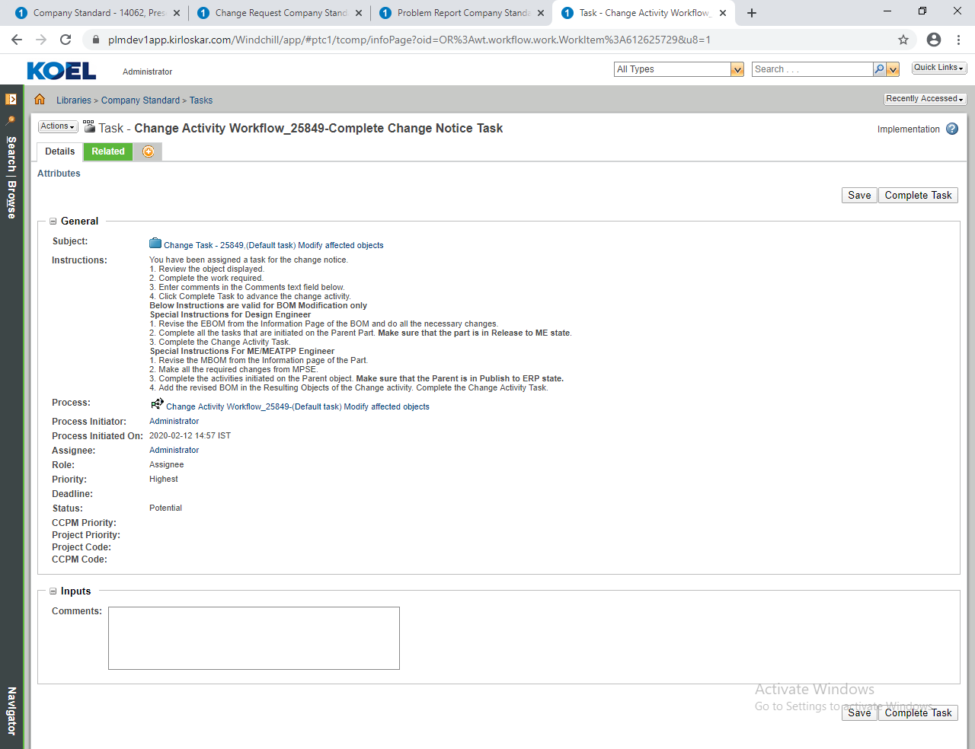
- Provide necessary comments .Then complete the ECN task, as seen in above figure

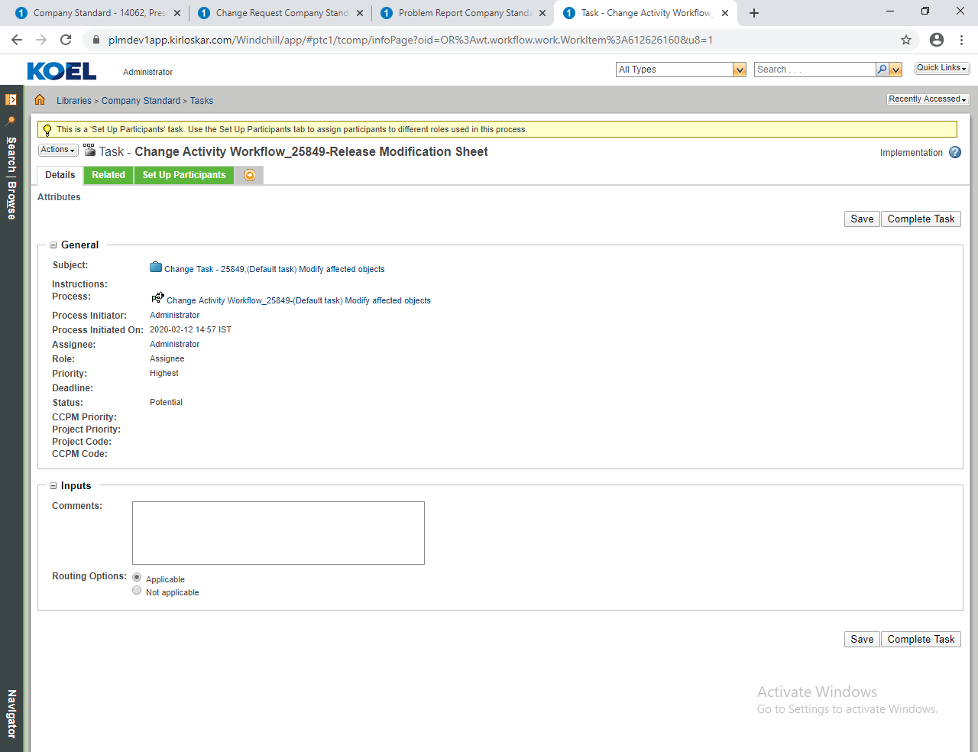
- In Release Modification Sheet task. Provide necessary comments
- Then select Routing options
- Applicable
- Not Applicable,
- If modification sheet is applicable then attach modification sheet and then complete the task.

5. Result:
All PR, ECR, ECN will be appear on “Changes” tab of company standard document for tracking.
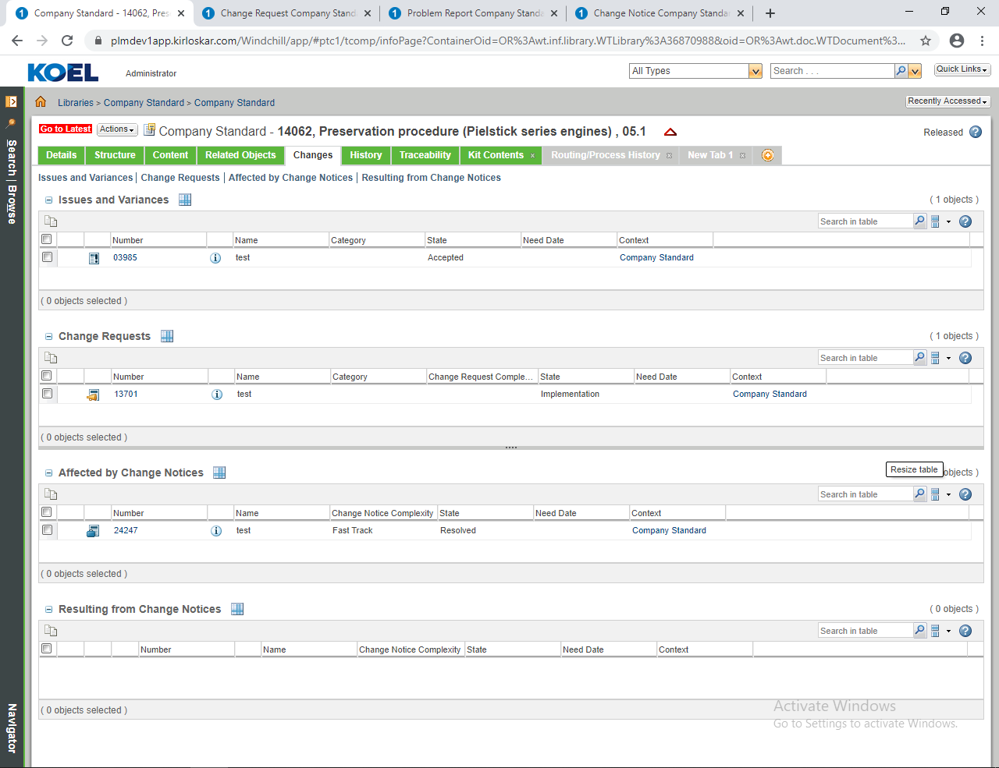
- In above figure if you click on Change tab , you can see ECR and ECN no.

